
DOKUZ EYLUL UNIVERSITY
ENGINEERING FACULTY
DEPARTMENT OF COMPUTER ENGINEERING


CME12522 PROJECT BASED LEARNING – II
FINAL REPORT
PROJECT – III

Word Puzzler

by
Volkan Ülker
Dırahşan Çağrı İrdemez
Tunahan Yanmaz

Lecturers
Asst. Prof. Dr. Özlem AKTAŞ
Res. Asst. Dr. Özge KART

IZMIR
15.05.2020

CHAPTER ONE
PROGRESS DESCRIPTION
This project is about creating a crossword puzzle game. The main purpose of it is that using list types like single, double and multi linked list to implement a puzzle type game; single linked lists are used for storing the words in the word list text file, multi linked lists are used for categorizing the words by their first letters and double linked lists are used for storing the highscore table.
Text files are used to store data in themselves. There are three text files as input to the program; the first one is used for creating the puzzle board, the second one is used for getting the solutions of the given puzzle board and the last one is used for storing the highscore table in it.
This is a game which can be played with two players, initially, the first player starts the game. The player can move his cursor anywhere on the board by using the arrow keys, when the player thinks that there should be a letter for that word, they press the letter on the keyboard and if it is a correct one the player gets some points and can keep guessing the letters on the same word. If the letter is not correct, the second player’s turn starts. When a word is completed the player who completes the word takes some points and a question, which asks the turkish translation of the word, appears on the screen, if the player answers the question correctly they get extra points. After filling the all empty spaces on the puzzle board, the player with the higher score wins and all the uncompleted words are displayed on the screen and also the highscore table with the name of the winner is shown on the screen.
The purpose and scope of the project is improving word knowledge in english and having fun, with this purpose anyone with the ability of writing and reading and also some knowledge about using competers are in the scope of this project. This game can be played in the classes or as a family activity.
The project was done in four weeks starting from the date 20th April. Most of the code was completed in the first three week and the last week was mostly testing and debugging. Some final bugs was fixed and some improvements was made before submitting the project.

CHAPTER TWO
TASK SUMMARY

Completed Tasks
-Reading files properly and taking words as single linked list. Then sorting then alphabetically by single linked list.
-Reading puzzle and finding uncompleted words.
-Converting single linked list to multiple linked list.
-High score table implementation with double linked list.
-Score calculation properly.
-Saving high score and bug fixes.

Additional Improvements
-The information messages have some delay between them to keep the game flow smoothly.
-The solution puzzle is displayable with num0 key.

CHAPTER THREE
EXPLANATION of algorıthms

Functions
Class Diagram

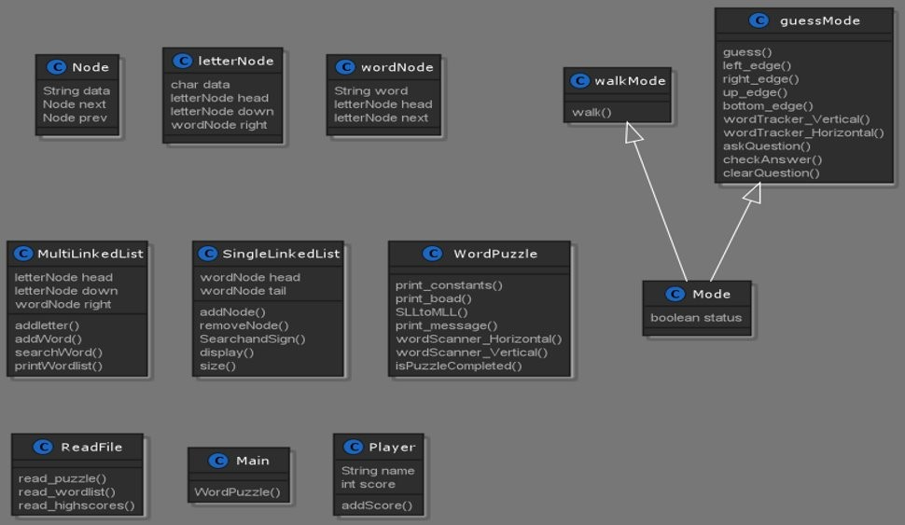

Algorithms and Solution Strategies
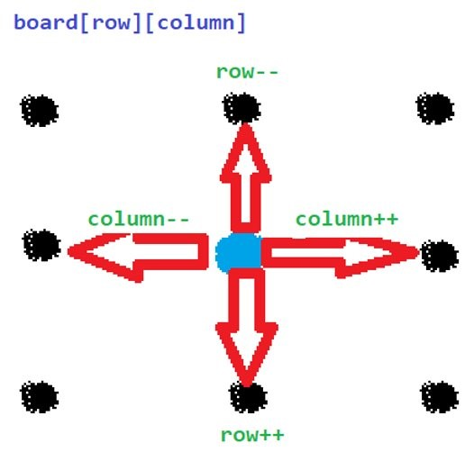

Walk Mode

In walk mode when we press a key, our board variables are changed, and our cursor is moved. For example, when we pressed the right arrow key our column variable is increased, and the cursor moves to the right. Other directions work with the same algorithm.

Flowchart of Guess a Letter Algorithm

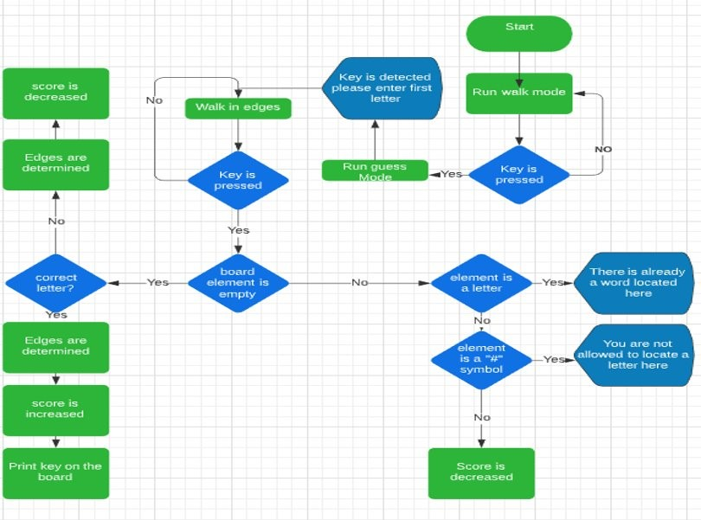

At the beginning of the program, walk mode is running and waits for a key when the key is pressed guess mode is running and “Key is detected please enter the first letter” message is printed and the program waits for another key and when the key is pressed we check four conditions first one is board element is empty or not. If the element is not empty, we check element is a letter or not. If the element is a letter “There is already a word located here” message is printed. If the element is not a letter then, we check the element is a “#” symbol or not. If the element is not a “#” symbol score is decreased. If the element is a “#” sharp symbol “You are not allowed to locate a letter here the message" is printed.

Algorithm of Determining Edges

Horizontal Edges

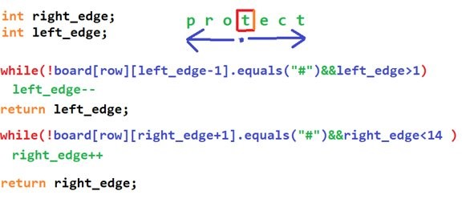

Assume our cursor on the “t” symbol, we check board element which on the right if that element is not equal to “#” cursor can move to the right and our right edge variable is increased until reaches fourteen or “#” symbol and other directions are tracked with the same algorithm.

Vertical Edges

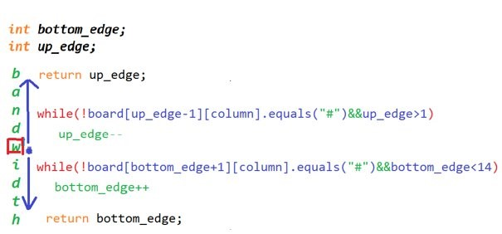

Thanks to these edges, we can restrict our cursor movement with the algorithm shown below.

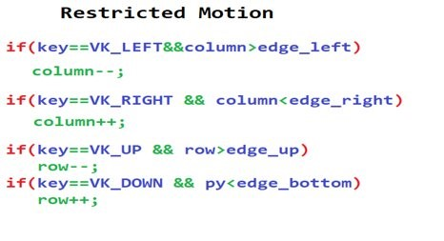

Transforming Single Linked List to Multi Linked List

After having the words in the text file in a linked list, the next process was putting them in a multi-linked list based on their first letter.
The add word part of the diagram is representing the part where we put the word to the node where it has the same letter with the first letter of the word.
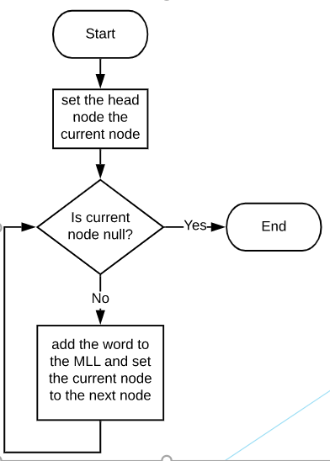

In order to find the place of a given word in the Multi Linked List, we loop through the nodes and compare the first letter of the word with the current node.
After that, we go through the right nodes of the current node until there is no right node and place the word we want.

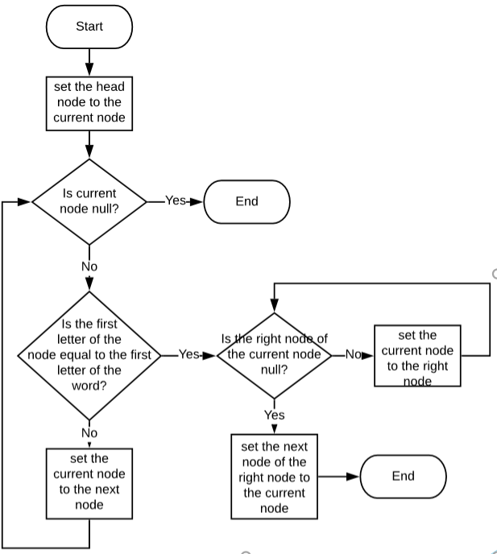

CHAPTER FOUR
PROBLEMS ENCOUNTERED
First problem we have encountered is, the documantation of this project was not enough to show a way to do that project. We did many parts of project by using our logic which makes game more sense.

Second problem was clearly about pandemic. We couldn’t make it face to face so we had to do it online. The online group working is not useful for that kind of projects. But we have managed it as well.

The third problem was file encoding system. Implementing turkish keyboard was a problem but we have managed it as well.

CHAPTER FIVE
conclusıon
In this project we learnt using and implementing single, double and multi linked list. We have improved our group working studying and we have experienced online group work as well.

Lastly, we have practised more on object orianted programming, solution algorithms and creating a project logic. With this last project experience, we can make better projects with group in our future works.

REFERENCES
- StackOverflow
https://stackoverflow.com/
- W3Schools
https://www.w3schools.in/data-structures-tutorial/linked-list/
- Geeksforgeeks
https://www.geeksforgeeks.org/linked-list-set-1-introduction/

AppendIx A
Poster/Web page of the Project
